Tordis Berstrand

University of Kent

**Jacobsen, Arne Emil (1902-1971)**

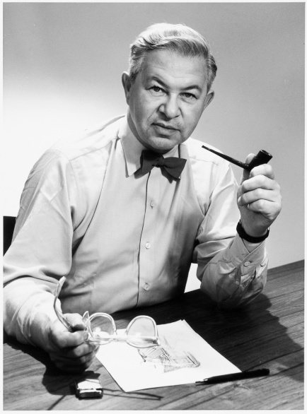

Arne Jacobsen

<http://www.purevillage.net/wp-content/uploads/2010/11/Arne_gro%C3%9F.jpg>

The Danish architect and designer Arne Jacobsen first trained as a bricklayer before studying architecture at the Royal Danish Academy of Fine Arts, Copenhagen (1924-27). Under the auspices of the director of furniture design, Kaare Klint, Jacobsen explored what would become hallmarks of Nordic Modernism – refined texture, integrity of form and advanced workmanship. After graduation, a successful architectural career was launched, yet it is Jacobsen’s furniture design, especially his chairs, which have brought the prolific designer international acknowledgement on a larger scale.

Jacobsen’s competition entry for the House of the Future (1929) set the scene early for a radical take on Modernism, which would also inform the design of the Bellevue Beach complex, Copenhagen (1932-35). While the show house introduced a Danish audience to the mechanical utopia of modern dwelling, the white-rendered beach environment was an equally alluring Functionalist manifestation of modern life. Jacobsen’s great business talent further secured several commissions for private houses (1931-43), and a number of public buildings in tune with the sharp and concise minimalism of North American INTERNATIONAL STYLE followed after World War II. The Royal Hotel and SAS Terminal, Copenhagen (1960) is an example of this.

It was especially in relation to these large-scale public schemes that the iconic furniture and household objects were developed. The chairs designed in the 1950s – the Ant (1952), Series 7 (1955), the Egg and the Swan (both 1958) – have all become design classics and are still produced by the Fritz Hansen furniture factory in Denmark. Jacobsen acknowledged the possibilities of industrial production, not least the use of synthetic materials, from early on and would move away from techniques and materials otherwise integral to Danish craft and design.

The development of Jacobsen’s distinctly modern architectural approach and style is seen in the town halls in Århus (1937-42) and Søllerød (1939-42), the Munkegård School, Søborg (1949-57) and the National Bank of Denmark (1961-78). A growing interest in garden design influenced the utilisation of outdoor areas as integral aspects of the overall spatial articulation of a site, an element most notably seen in Jacobsen’s design for St Catherine’s College, Oxford (1960-63). Jacobsen landed this commission as the first non-native architect to design an English college. Involved with radical Danish thinkers such as Poul Henningsen, Jacobsen also became Professor in Architecture at the Academy in Copenhagen (1956-65), as well as honorary member of the American Institute of Architects and the Royal Institute of British Architects towards the end of his life.

**List of works**

1929 Own house, Charlottenlund, Denmark

1935 Novo therapeutic laboratory, Frederiksberg, Denmark

1946-54 Søholm, Klampenborg, Denmark (where Jacobsen also lived)

1969 Royal Danish Embassy, London, United Kingdom (built by Dissing+Weitling, 1977)

1969 Rødovre Library, Rødovre, Denmark

**References and further reading**

Faber, T. (1964) *Arne Jacobsen*, Trans. Rockwell, E., London: Tiranti.

Tøjner, P. E. & Vindum, K. (1996) *Arne Jacobsen – Architect & Designer*, Copenhagen: Danish Design Centre.

Thau, C. & Vindum, K. (2001) *Arne Jacobsen*, Trans. Abrahamsen, M. G., 2nd edition, Copenhagen: Danish Architectural Press.

**Visual material:**

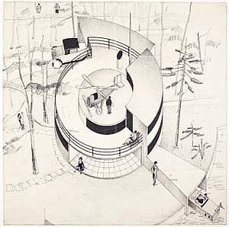

House of the Future, sketch,1929

Copyright: Royal Library, <http://www.kb.dk/da/nb/tema/webudstillinger/skitser/index.html>

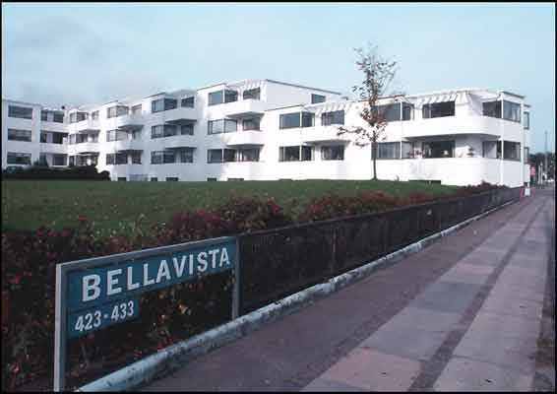

Bellavista housing, Klampenborg,1932-35

Copyright: Royal Danish Academy of Fine Arts, School of Architecture Library,

<http://www.arkitekturbilleder.dk/bygning-Bellavista-6>

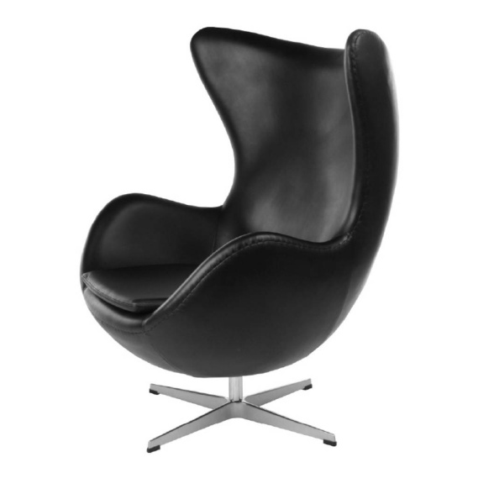

Egg Chair, 1958

<http://cdn.webshopapp.com/f/zznv0y/arne-jacobsen-egg-chair-in-black-leather.jpg>

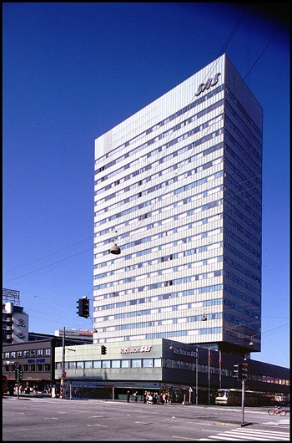

The Royal Hotel and SAS Terminal, Copenhagen, 1960

Copyright: Royal Danish Academy of Fine Arts, School of Architecture Library,

<http://www.arkitekturbilleder.dk/bygning-SAS-hotel-tidligere-Royal-Hotel-37>

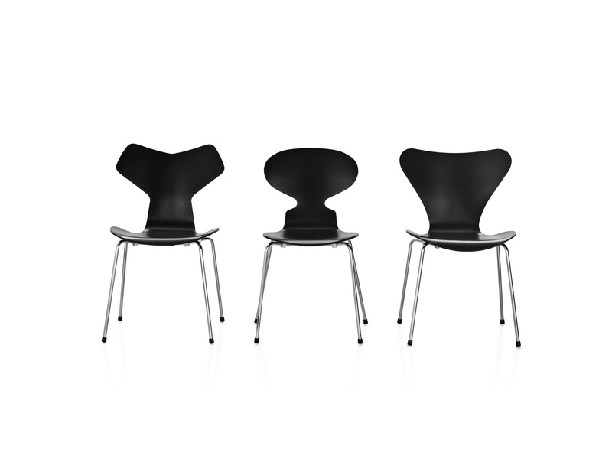

Grand Prix, Ant and Series 7, 1952-57

Copyright: Fritz Hansen, <http://www.fritzhansen.com/en/fritz-hansen/asset-bank?append=action/viewAsset?id=430&index=1&total=24&view=viewSearchItem>

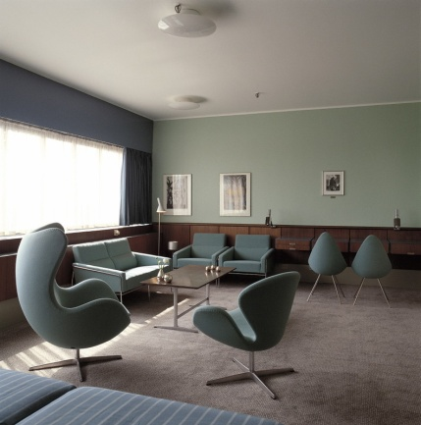

Jacobsen’s private Room 606 at The Royal Hotel and SAS Terminal with various pieces of furniture: the Egg, the Swan, the Drop, Series 3302 and 3300, 1956-1958

Copyright: Fritz Hansen, <http://www.fritzhansen.com/en/fritz-hansen/asset-bank?append=action/viewAsset?id=383&index=1&total=24&view=viewSearchItem>

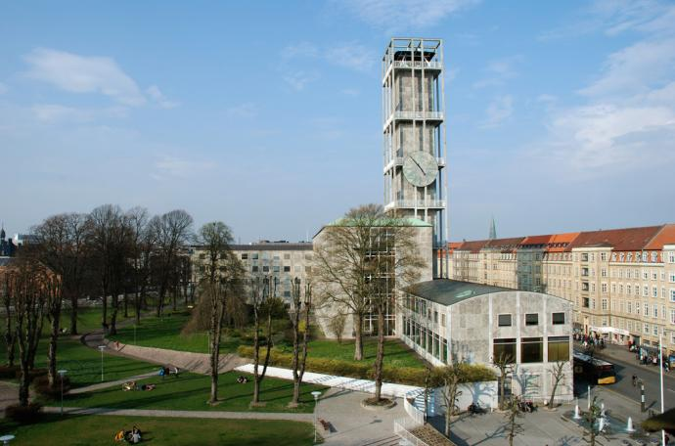

Århus Town Hall, 1937-42

Copyright: Heritage Agency of Denmark, <http://www.kulturarv.dk/1001fortaellinger/da_DK/aarhus-raadhus/images/newest/1/7-aarhus-raadhus-lars-bjarke-christensen>

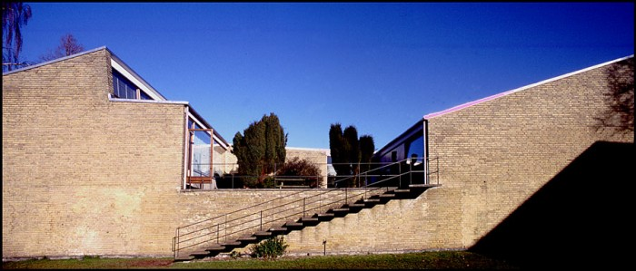

The Munkegård School, Gentofte, 1949-57

Copyright: Royal Danish Academy of Fine Arts, School of Architecture Library, <http://www.arkitekturbilleder.dk/bygning-Munkegårdsskolen-66>

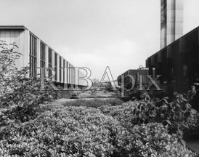

St Catherine’s College, Oxford, 1960-63

Copyright: ribapix.com, <http://www.ribapix.com/index.php?a=advanced&s=item&key=XYToyOntzOjM6IjAwNCI7czo0OiIzMDM4IjtzOjM6IjAwNyI7czo2OiJveGZvcmQiO30=&pg=3>

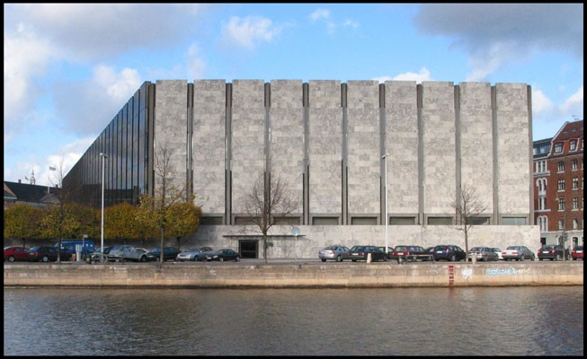

The National Bank of Denmark, Copenhagen, 1961-78

Copyright: Royal Danish Academy of Fine Arts, School of Architecture Library, <http://www.arkitekturbilleder.dk/bygning-Danmarks-Nationalbank-4>